Paper title: A generalisation of REM models for camera traps or acoustic sensors.

Introduction

- Introduction
  - Monitoring the size of populations is necessary for maintaining biodiversity.
  - Monitoring can be done in different ways, by a direct count or through taking samples. (Pollock 2002)
  - Methods for collecting samples can vary from human surveys to sensor records, such as the results from cameras or sound recorders placed throughout an environment.
  - Sensors are growing in popularity, as they are efficient, relativity cheap and non-invasive. (Gese 2001)
  - Samples collected from sensors can then be used in methods like REM or Capture-Recapture in order to estimate density of the population.
  - Current methods are not suitable for all species, so some species have no, or unreliable, population information.
  - These species are often difficult to capture on camera, but are easier to detect using an acoustic sensor (Rogers 2013), such as bats (O’Farrell 1999), whales (McDonald 1998), and potentially for species such as monkeys.
  - But these data collection methods are incompatible with REM, because the width of the sensor can be greater than 90, and because the animal may give off a directional signal
  - We are going to extend REM methods so that it can be used with acoustic data as well as data collected via camera traps
- Hypotheses:
- The analytical model can accurately predict density when the assumptions of a homogeneous environment and straight-line animal movement are met.
- The accuracy of the model is not affected by changes in the movement model, however the precision of the analytical models are affected
- The precisions of the analytical models are also affected by sampling effort, radius of detection, call angle and detection angle, animal speed and density.
- Aims:
- In this study we created a general model, as an extension to the REM, to estimate absolute abundance from count data from acoustic or visual sensors. Where the angle of detection of the sensor can vary from 0 to 360°, and the signal given off from the animal can be between 0 and 360°.
- We tested the model using simulations in order to:
  - Access the validity, i.e. that the bias is equal to 0
  - To be able to give suggestions for best practice

Methods

In this section we outline the general process for deriving the models. However, as the full derivation is long, it is included in the supplementary material.

The model presented by Rowcliffe et al. (2008) is derived assuming a sensor with a viewing angle less than π/2 and so the sensor is modeled as a circular segment with a central angle between 0 and π/2. While they named this central angle θ, here we will call it θ_{s}.

Furthermore, as they modeled a camera trap, an animal can be detected from any direction. We however want to relax this assumption to allow for acoustically detected animals. We therefore model the animal as having an associated call angle θ_{a}.

In general we are aiming to derive models for any sensor angle, θ_{s}, between 0 and 2π and any call angle, θ_{a}, between 0 and 2π. We can easily derive the gas model which is the case where θ_{a} = 2π and θ_{s} = 2π.

We assume that animals are in an homogeneous environment, and move in straight lines of random direction with velocity v. We allow that our sensor can detect animals at a distance r and that if an animal moves within this detection region they are detected with a probability of 1, independent of distance from the sensor while animals outside the region are never detected.

We then consider movement from the reference frame of the animals so that now, all animals are stationary and randomly distributed in space, while the sensor moves with velocity v. If we calculate the area covered by the sensor during the study period we can estimate the number of animals it should encounter. As a circle moving through space, the area covered by the sensor per unit time is 2rv. The number of expected encounters, z, for a survey of duration t, with an animal density of D is
z = 2rvtD.
However, in practice we have the opposite situation. We know the number of encounters and want to estimate the density. We do this be simply rearranging to get
D = z/(2rvt).
For different values of s and a, the only thing that changes is that the area covered per unit time is no longer given by 2rv. Instead of the sensor having a diameter of 2r, the sensor has a complex diameter that changes with approach angle. If we call this average diameter or profile p, the rest of the derivation is just calculating this value for all values of a and s. However, different regions of this two dimensional parameter space have noncontinuously different models, with different derivations. Therefore we have to identify the regions for which the derivation is the same, and then separately derive p for each region.

Figure 'regions' shows the different regions with the upper right being the gas model as derived above and p141 is the model from Rowcliffe et al. (2008). Parameter space is broadly split into three rows (θ_{a} ≤ π, π ≤ θ_{a} < 2π and θ_{a} = 2π) and four columns (θ_{s} ≤ π/2, π/2 ≤ θ_{s} ≤ π, π ≤ θ_{s} < 2π and θ_{s} = 2π.) The equation for p in each region is denoted by three numbers referring to rows, columns and region within that row/column.

For regions with profiles that are more complex than a circle we need to explicitly write functions for the width of the profile for every approach angle. We then use these functions to find the average profile for all approach angles by integrating across all 2π angles of approach and dividing by 2π. In practice, as the models are all left/right symmetrical we can integrate across π angles of approach and divide by π.

To work through one example that contains both a and s we will examine p321. Following Rowcliffe et al. (2008) we use γ_{i} to denote the focal angle which is the angle we integrate over. The subscript i distinguishes different angles. For model p321 we examine γ₄ with γ₄ = π/2 being an approach angle directly towards the sensor (see Figure 'p321').

We can see that, rotating anticlockwise, from γ₄ = π/2 the detection region is 2r wide. However, an animal will only be detected if it approaches the detector so that as it enters the detection region the angle between the direction of approach and the direction towards the sensor is less than θ_{a}/2. The width of the profile within which the animal will be detected is therefore 2rsin(θ_{a}/2). At γ₄ = θ_{s}/2 + π/2 – θ_{a}/2 we reach a point where the right hand side of the profile (relative to the approach direction) isn't limited by the call angle but is limited by the detection angle instead. From here the profile width is therefore rsin(θ_{a}/2) + rcos(γ₄ – θ_{s}/2). Finally, at γ₄ = 5π/2 - θ_{s}/2 - θ_{a}/2 an animal can again be detected from the right side of the detector; the approach angle is far enough round to see past the 'blind spot' of the sensor. In this region, until γ₄ = 3π/2, the width of the profile is again 2rsin(θ_{a}/2). We have therefore characterised the profile width for π radians of rotation (from directly towards the sensor to directly behind the sensor.) To find the average profile width for any angle of approach, we integrate these functions over their appropriate intervals of γ₄ and divide by π.
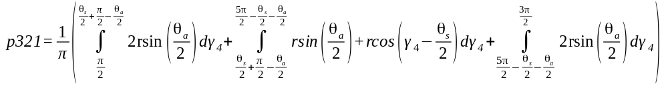 eqn 1
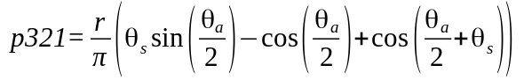. eqn 2

Then, as with the gas model, this term is used to calculate density
D = z/vtp321.

We can also see what causes this model to be discontinuously different to p322. Examine the profile at γ₄ = θ_{s}/2 + π/2 (the profile is perpendicular to the edge of the blind spot.) We see that there is potentially a case where the left side of the profile is rsin(θ_{a}/2) while the right side is zero. This profile doesn't exist if we return to the full 2rsin(θ_{a}/2) profile before γ₄ = θ_{s}/2 + π/2. Therefore we solve 5π/2 - θ_{s}/2 - θ_{a}/2 < θ_{s}/2 + π/2. We find that this new profile only exists if θ_{a} < 4π – 2θ_{s}. This inequality defines the line separating p321 and p322.

While specifying the models had to be done by hand, the calculation of the solutions was done using SymPy (SymPy Development Team 2014) in Python.

The models are checked for errors with a number of tests. They are checked against each other by checking that adjacent models are equal at the boundary between them. Models that border θ_{a} = 0 should have p = 0 when θ_{a} = 0 and this is checked for. We checked that all solutions are between 0 and 2r and that each integral, divided by the range of angles that it is integrated over is between 0 and 2r.

To make the application of these models simple, we have included an R script in S1.

- REM extensions
  - Very brief description – explaining discontinuity for angles
  - The assumptions of the model
  - Simple example
  - Reference to package

- Simulation methods
  - General simulation
    - Simulation created in C++
    - A homogeneous world with periodic boundaries is created,
    - A single sensor placed in the middle if the world, with a given width and radius
    - The world is populated with a known density of animals of up to 70animals per km² (Demuth 1981), which are placed randomly at the beginning of each simulation.
    - The animals move through the world with a set average speed, and movement strategy
    - When an animal moves through the edge of the detector range it is captured
    - The total number of capture event is summed for each simulation and the relevant model applied and the density estimated
    - The true density in the simulation is compared to the estimated density and the bias calculated
  - Subsampling to access variance
    - In order to calculated the effect that variables have precision of the results
      - Values are subsamples with respect to time, density and call width.
      - A range of speeds between 0.00012m/s & 0.46m/s (Carbone 2005) were simulationed
      - Along with a range of correlated walks with set maximum turn angle, (straight-line movement and random walks are special cases)

Results

- The model equations
  - Number of different model extensions that have been calculated
  - Figure with model numbers in which can be used to reference the appendix?
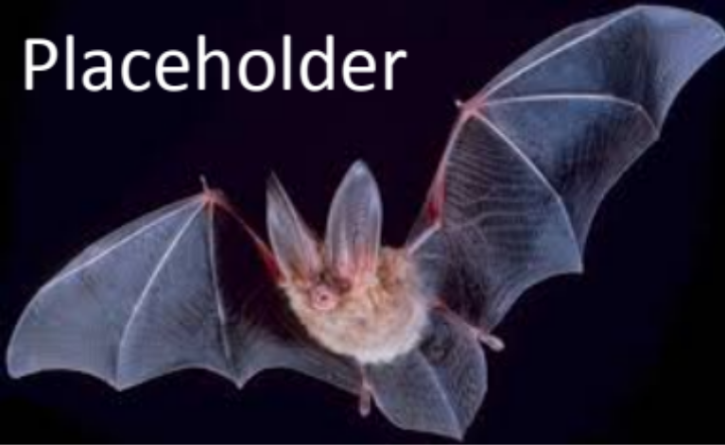
Figure 1: Models numbered
  - …
- Bias is approximately zero for all models as demonstrated by simulation:
  - At a given speed, density, sampling effort, sensor radius, and a given movement strategy
Figure 2:Figure of Bias vs model
- The expected number of captures will vary, dependent on the system that is being monitored and how it is monitored. This will affect the precision of the estimated:
  - Animal movement strategy
  - Speed of movement
  - Density of the animal
  - Sampling effort
  - Radius of the sensor
Figure 3: Multiple figures of how variance changes with variables
Discussion
- Developed a number of models that can be used to estimate density from acoustic and optical sensors
- These models are accurate
- Implications for best practice:
  - Densities of above X converge quickly to a stable mean
  - Animals which have an average speed of greater then X
  - Surveys of at Xhrs of effort produce stable results
- Aspirational stuff for the future:
  - Consider animals moving in groups
  - Incorporating more realistic movement strategies
  - Moving detectors
  - Trigger delays and time expansion

References

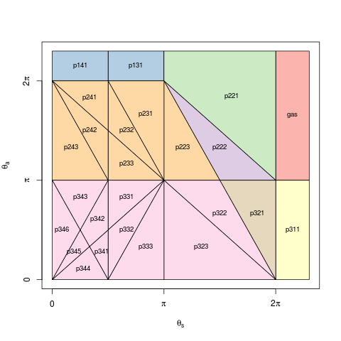
Figure 'regions'. The independently derived models for the whole of parameter space. Regions whose solution for p are equal are coloured similarly. Models are numbered by their row, column and then numbered within that area. The models for a = 2π or s = 2π are shown by extending these regions outside of their real boundaries.

